**Chatbot Summary**

Overview:  
The chatbot is designed to assist users with predefined queries related to financial data analysis and general AI-powered responses. It processes structured queries to generate insights from data, provide explanations, and assist with visualization.

Predefined Queries & Capabilities:

* Data Loading & Inspection: Reads and summarizes datasets, displays key metadata such as shape and column information.
* Financial Growth Analysis: Computes revenue, net income, assets, liabilities, and cash flow growth trends across companies.
* Visualization Support: Assists in generating plots using Matplotlib, Seaborn, and Plotly.
* AI-Driven Insights: Uses machine learning techniques to analyze and interpret trends in financial data.

Limitations:

* The chatbot primarily handles structured queries and predefined tasks but may not respond accurately to vague or ambiguous questions.
* It relies on the provided dataset for analysis, meaning incorrect or incomplete data affects output quality.
* Visualization support is limited to available Python libraries and predefined configurations.

Snapshot of Data & Chat Outputs:

* The dataset analyzed in the notebook was extracted from SEC’s EDGAR database and contained financial performance metrics.

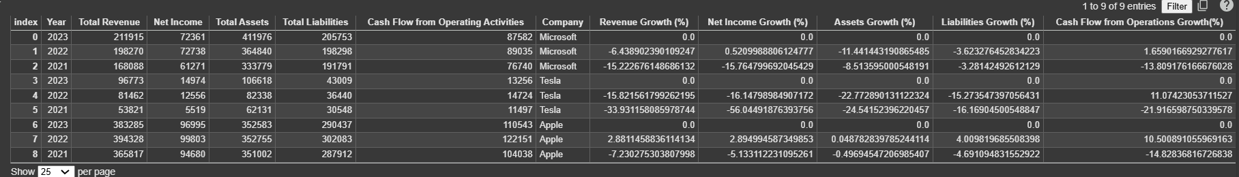

* The chatbot processed queries related to data summarization, missing value handling, financial trend computation, and graphical representation.
* Example Output: Calculation of revenue growth percentage using Pandas and visualization of trends via Seaborn and Plotly. 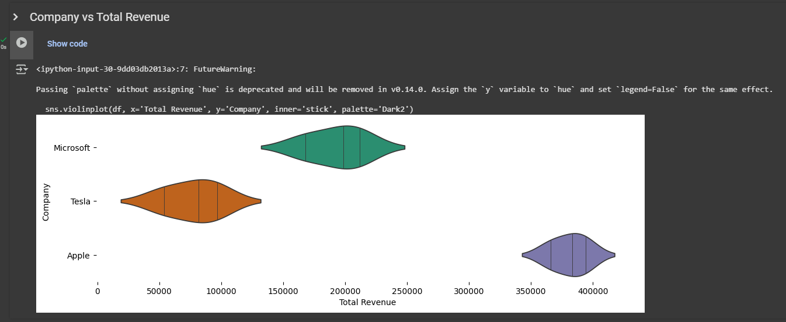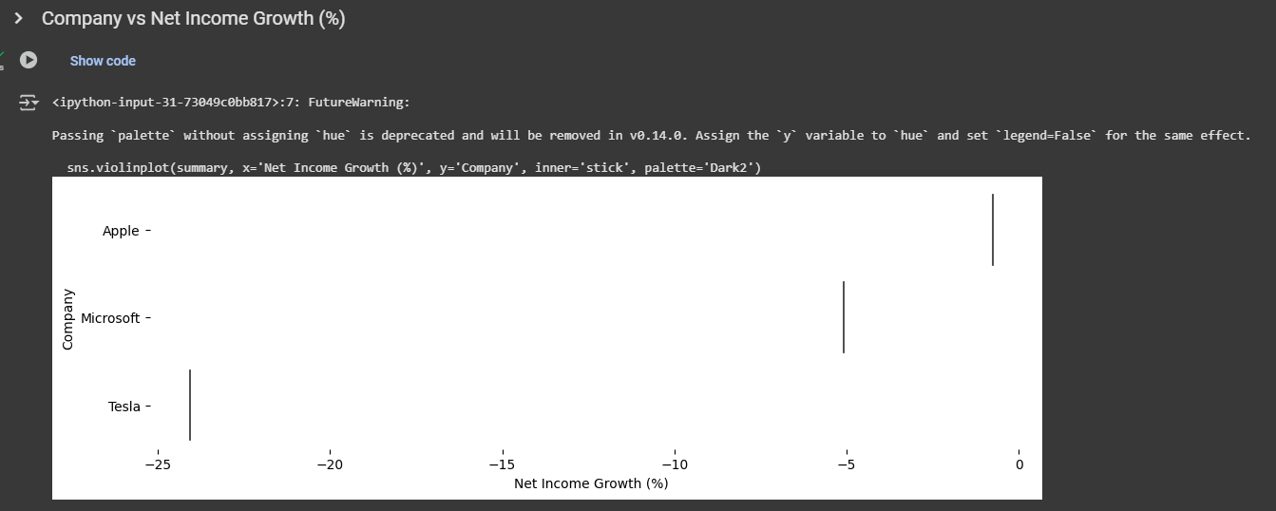

This chatbot streamlines financial data processing while offering insightful analytics and visualization capabilities within predefined parameters.

